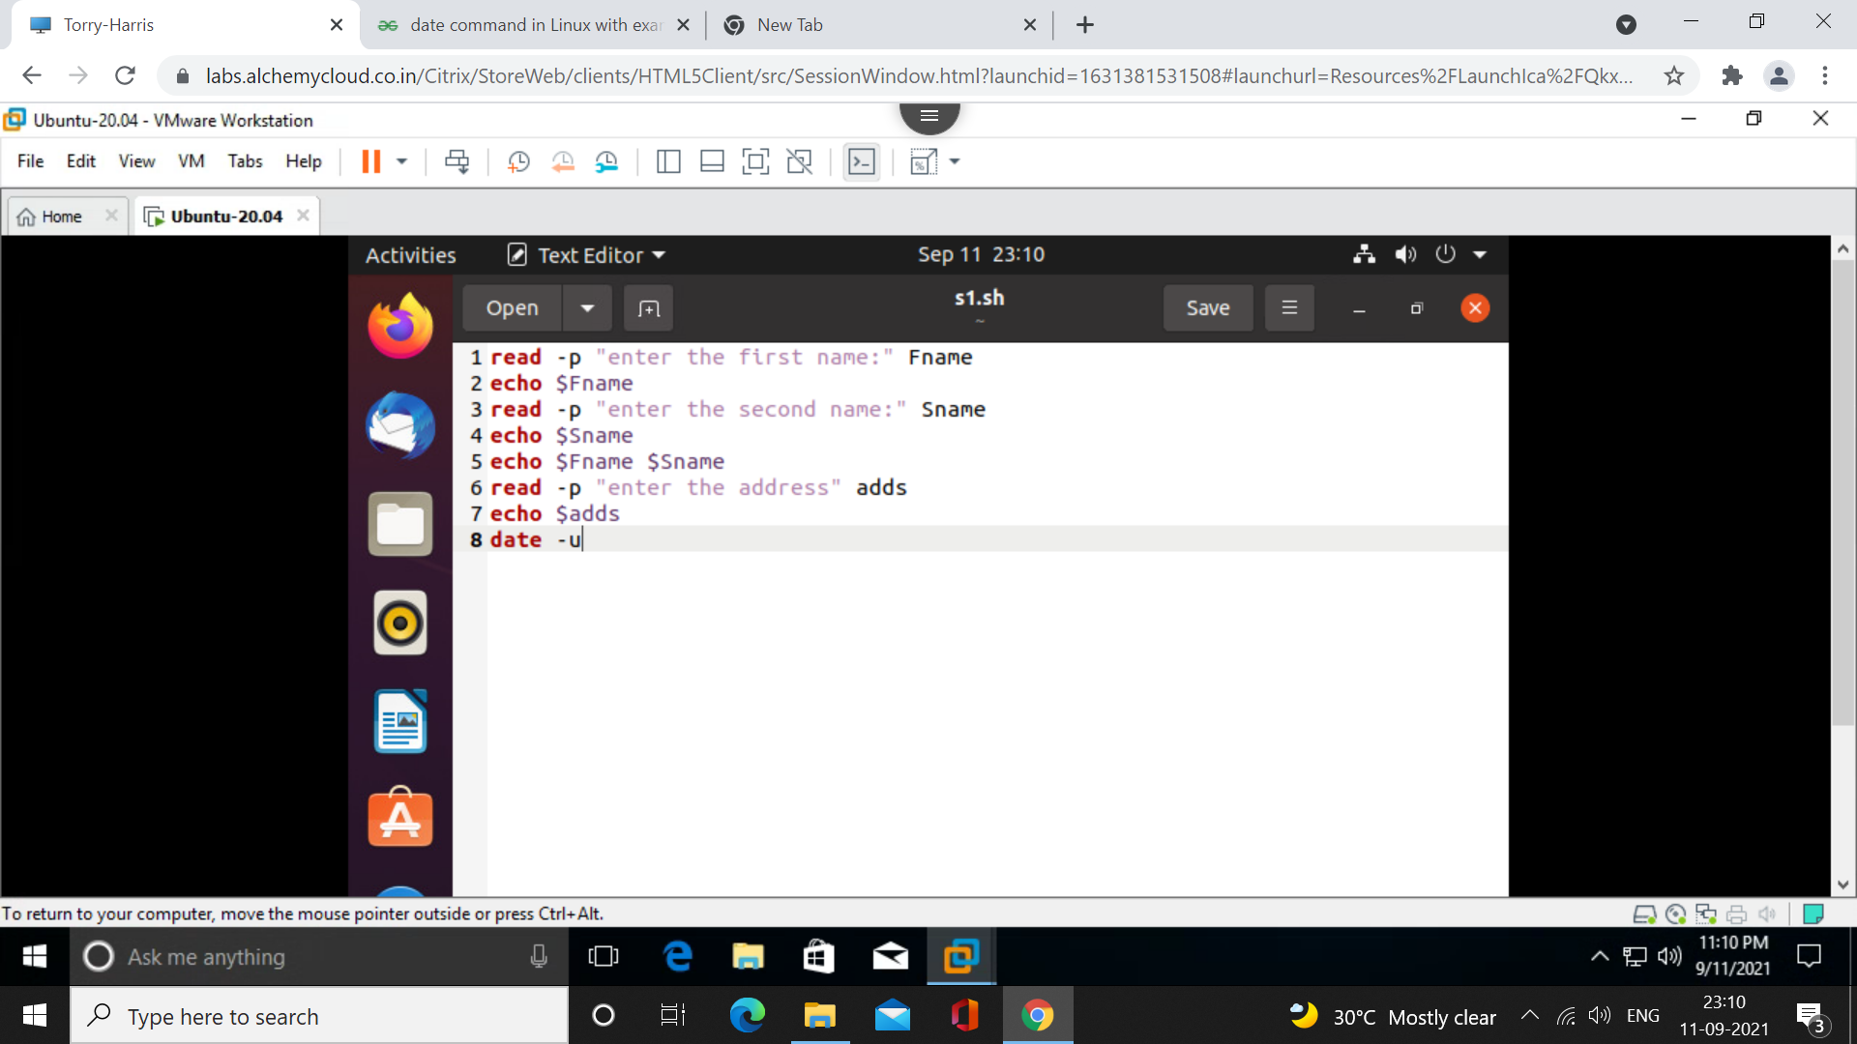

Shell Script to print the name, address, date.

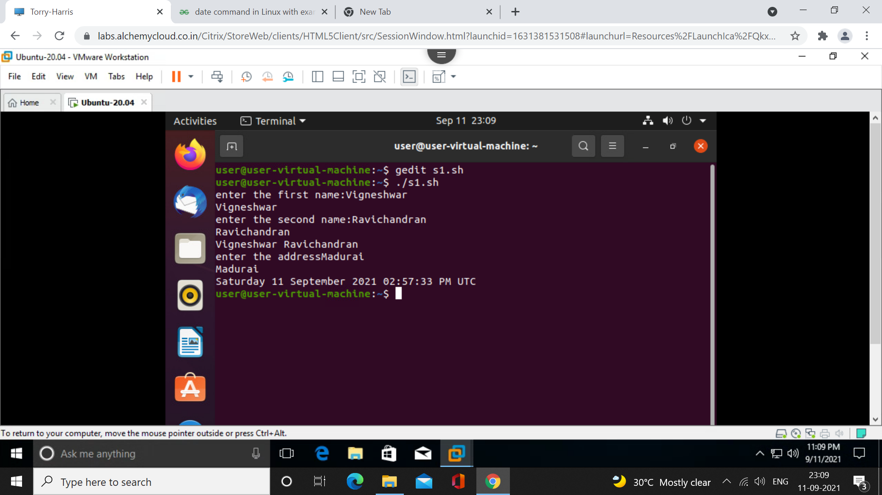

Output

_____________________________________________________________________________________

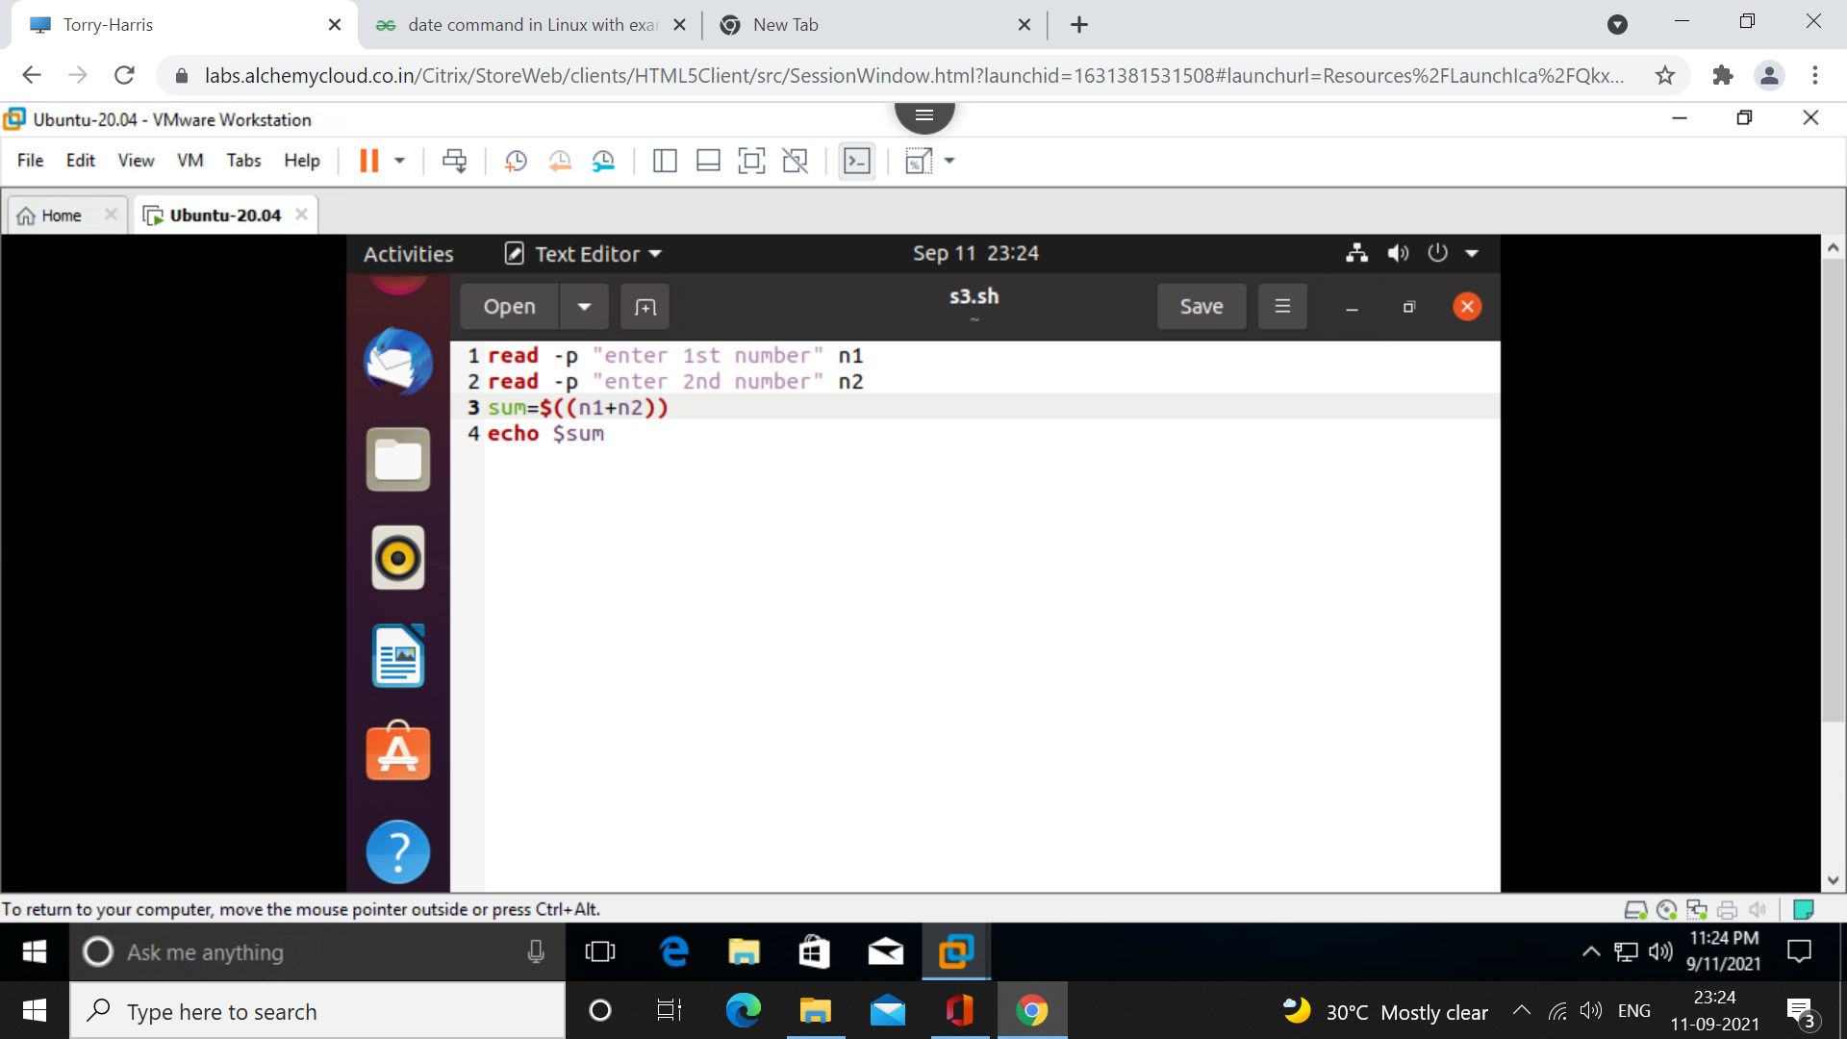

Sum of two numbers

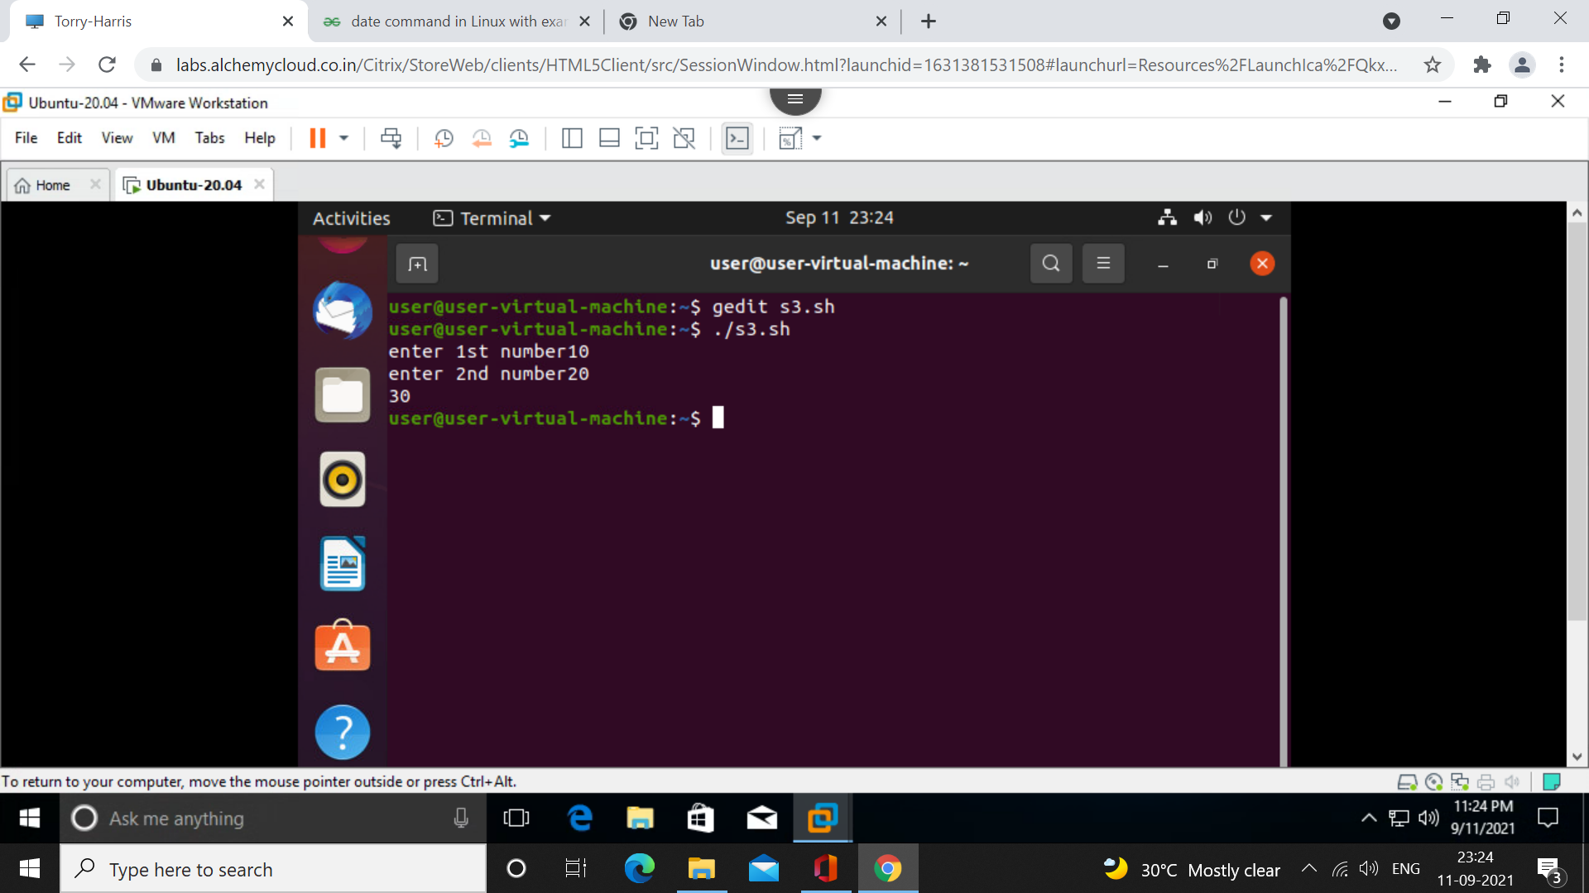

Output

_____________________________________________________________________________________

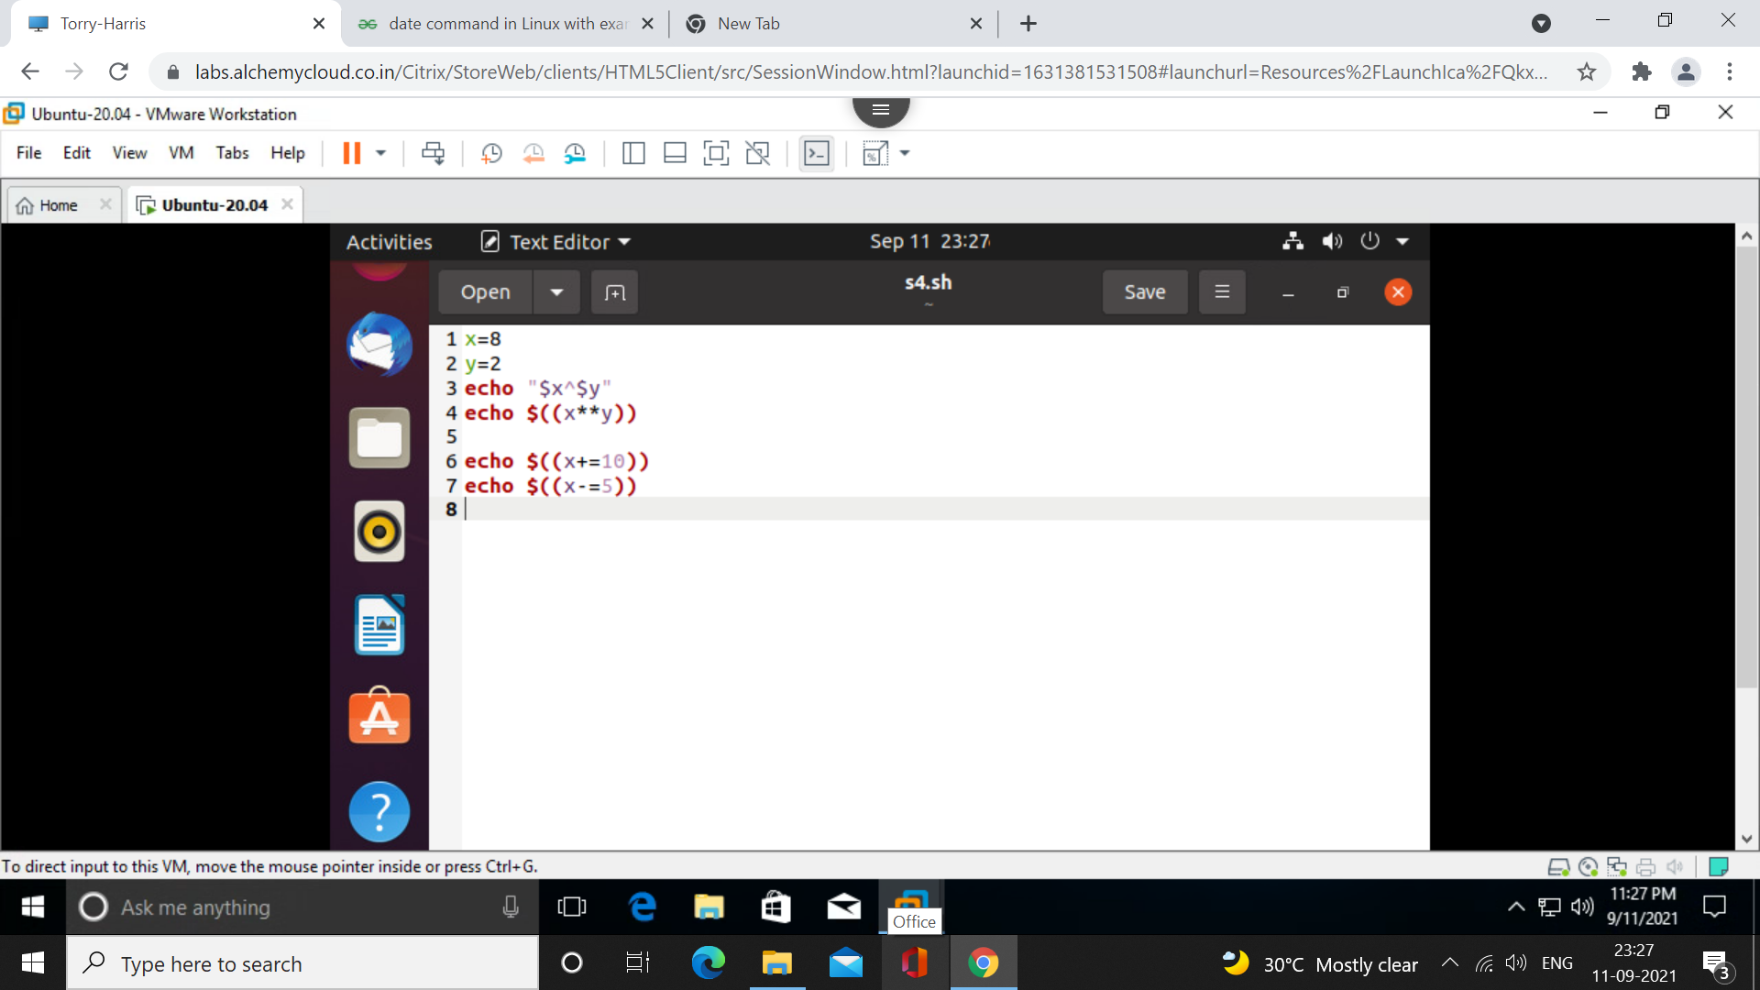

Exponential

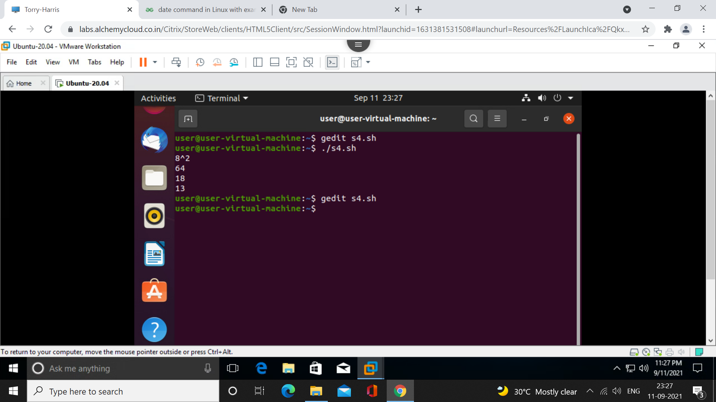

Output

_____________________________________________________________________________________

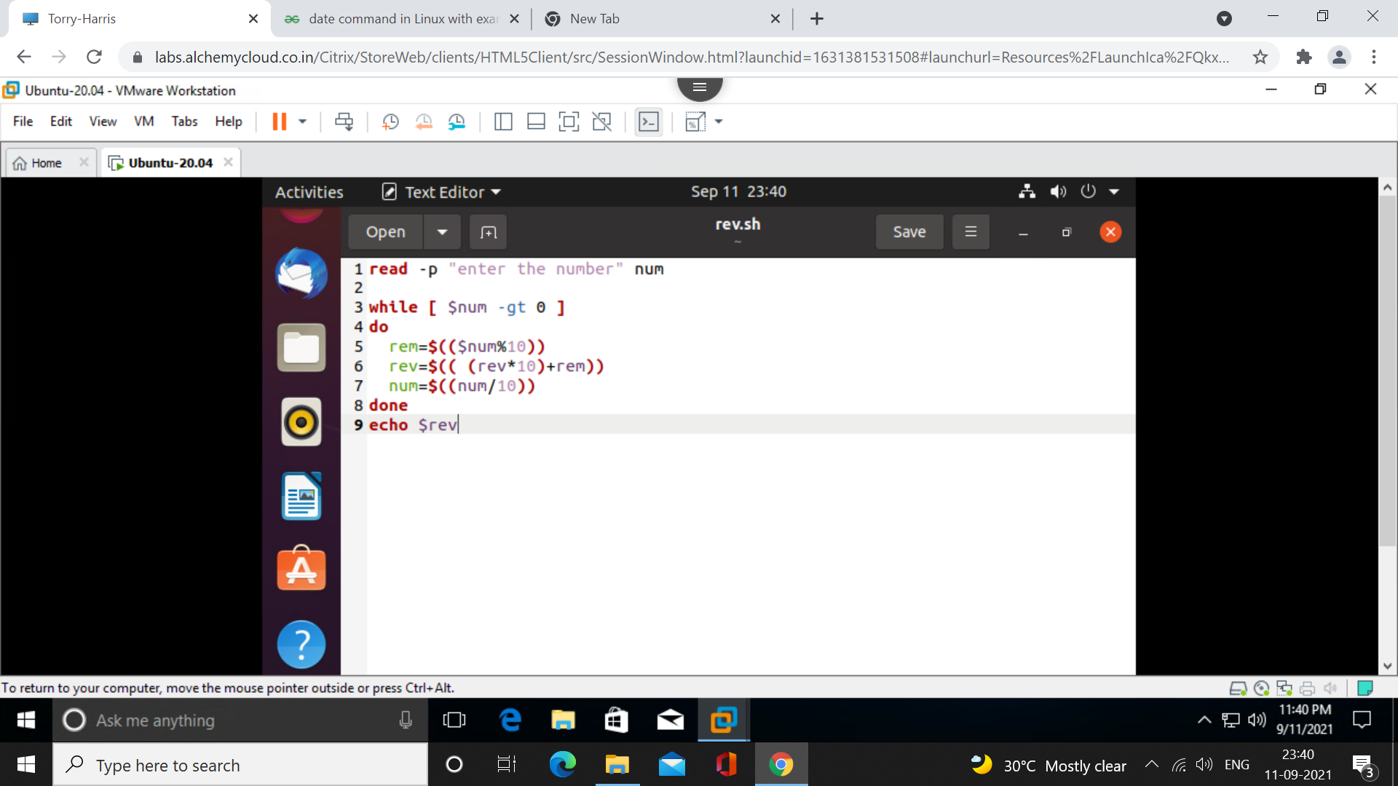

Reversing the number

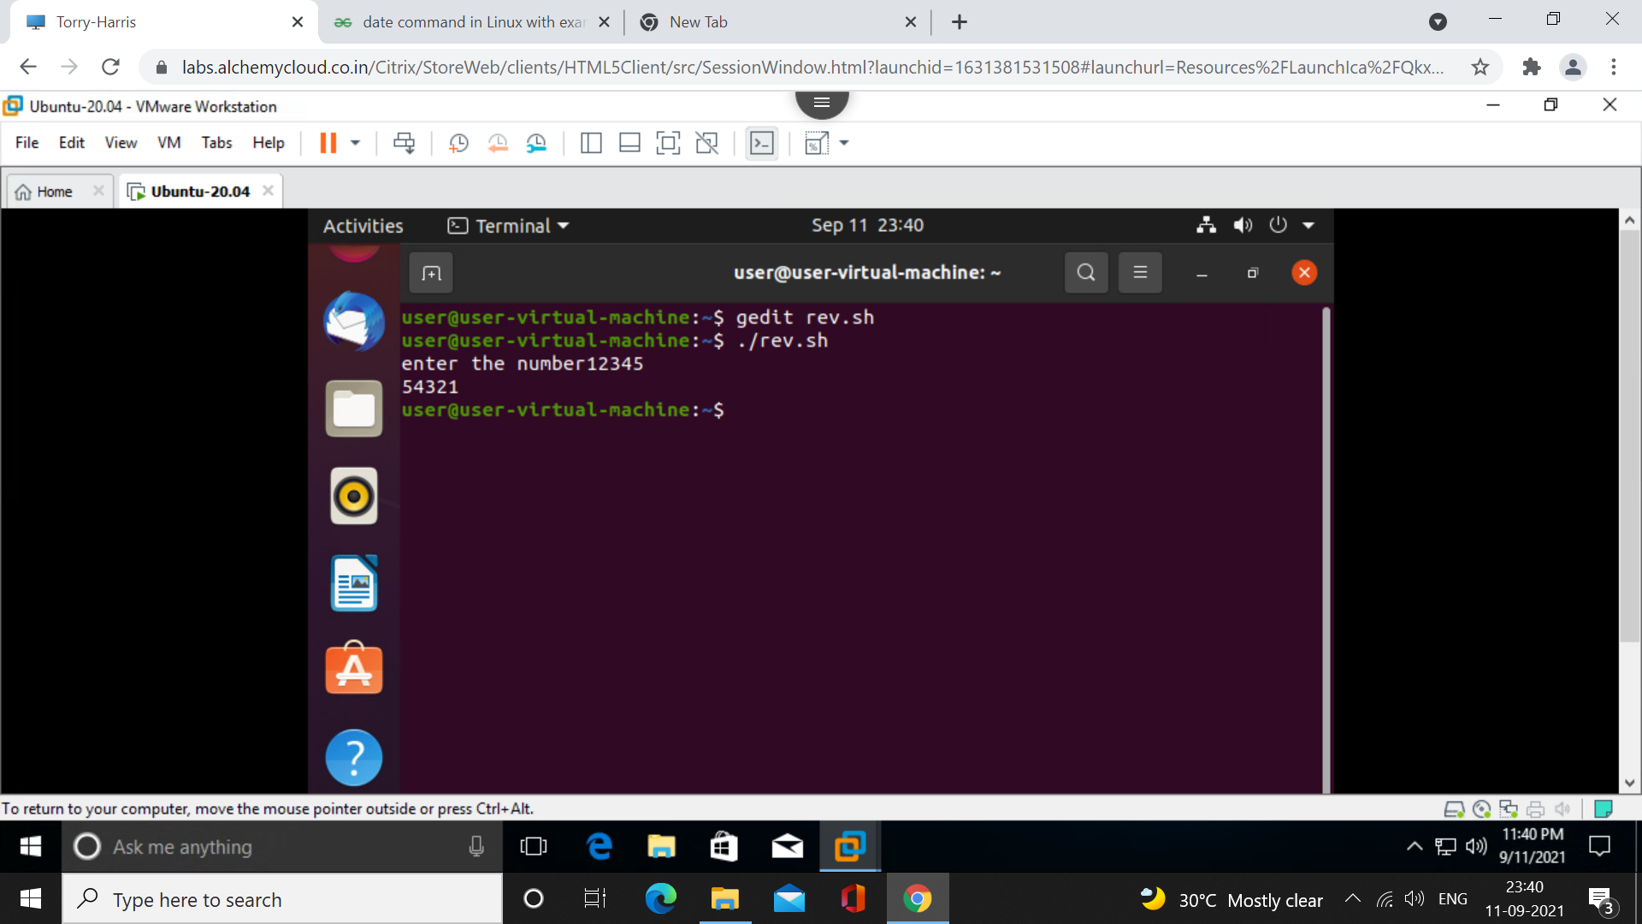

Output